**Activity 1**

**Finance Management App**

**Project Overview:**

The Finance Management App is designed to empower families, individuals, and small businesses to take control of their finances. This app offers an intuitive platform for managing income, tracking expenses, setting financial goals, and accessing expert financial advice. By providing tools to create realistic budgets and monitor spending, the app helps users achieve financial stability and reduce stress**.**

**Problem Statement:**

Many families and small businesses struggle with financial planning due to inadequate tools and lack of guidance. This leads to overspending, poor savings habits, and difficulty in reaching financial goals. A comprehensive and user-friendly budget planner is essential to bridge this gap, offering a structured approach to financial management and informed decision-making.

**Goals:**

* Financial Empowerment:

Empower families/small businesses to take control of their finances and make informed decisions.

* Improved Financial Health:

Help families/small businesses achieve financial stability and reach their long-term financial goals.

* Reduced Financial Stress:

Alleviate financial stress by providing a clear overview of income and expenses.

**Objectives:**

1. Input Income resources
2. Show categories for expenses (fixed)
3. User can also add their desired categories
4. Specific financial goals with desired amount and deadline
5. Guide users in creating a realistic budget based on their income
6. Notifications when users are nearing their budget limits
7. Articles, tips, and tutorials on budgeting, saving, and investing
8. Allow users to add custom expense categories based on their specific needs.

**Customers:**

The app primarily targets the following customer groups:

* Families: For household expense management and goal-oriented savings.
* Individuals: To facilitate personal budgeting, saving, and financial health tracking.
* Small Businesses: To monitor business expenses, income streams, and profitability.

**Stakeholders:**

Key stakeholders include:

* Families: Users managing shared household finances.
* Individuals: Young professionals, students, and retirees seeking personal financial control.
* Small Companies: Entrepreneurs and small business owners tracking business budgets.
* Financial Advisors/Experts: Professionals offering articles, tutorials, and tips integrated into the app.
* Developers: Responsible for building and maintaining the app, ensuring functionality and user satisfaction.
* Investors: Supporting the app's development and expansion to new features and markets.

**Tools:**

Flutter  
 UiZard

**Scope:**

The scope of a Finance Management App for families, individuals, and small companies focuses on helping users achieve financial stability and make informed budgeting decisions.

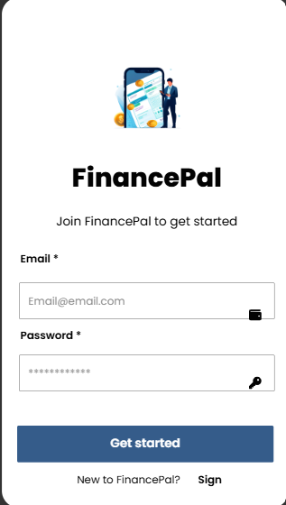

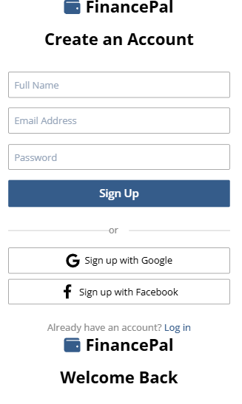

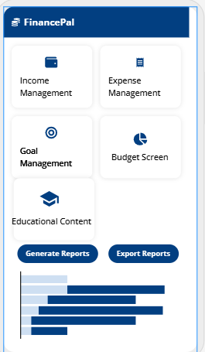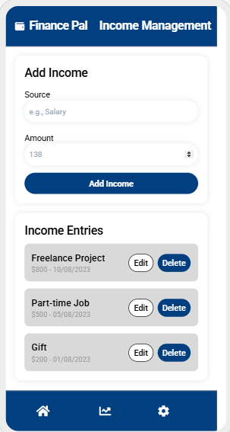

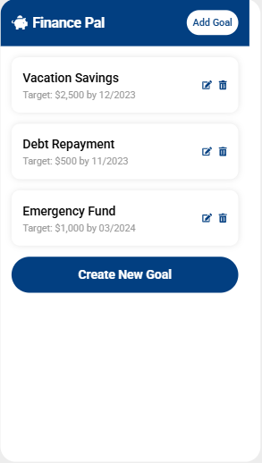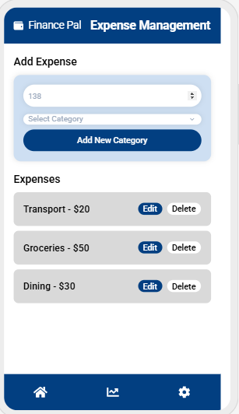

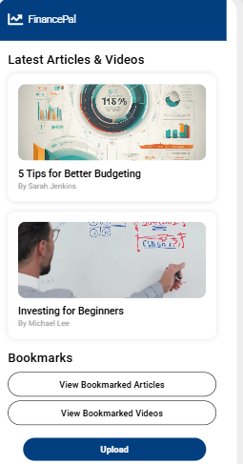

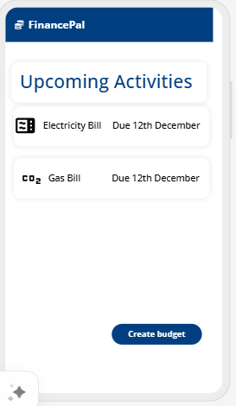

Gantt Chart:

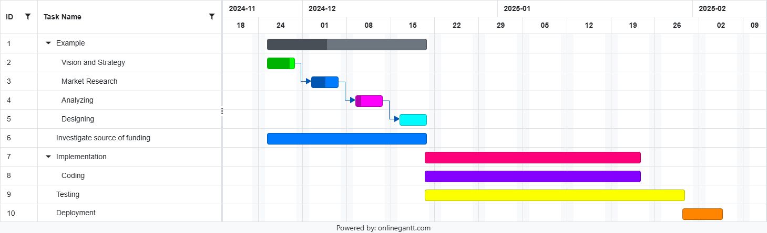

|  |  |  |  |  |  |  |  |  |  |  |  |  |  |  |  |  |  |  |  |  |  |  |  |  |  |  |  |  |  |  |  |  |  |  |  |  |  |  |  |  |  |  |  |  |  |  |  |  |  |  |  |  |  |  |  |  |  |  |  |  |  |  |  |  |  |  |  |  |  |  |  |  |  |  |  |  |  |  |  |  |  |  |  |  |  |  |  |  |  |  |  |  |  |  |  |  |  |  |  |  |  |  |  |  |  |  |  |  |  |  |  |  |  |  |  |  |  |  |  |  |  |  |  |  |  |  |
| --- | --- | --- | --- | --- | --- | --- | --- | --- | --- | --- | --- | --- | --- | --- | --- | --- | --- | --- | --- | --- | --- | --- | --- | --- | --- | --- | --- | --- | --- | --- | --- | --- | --- | --- | --- | --- | --- | --- | --- | --- | --- | --- | --- | --- | --- | --- | --- | --- | --- | --- | --- | --- | --- | --- | --- | --- | --- | --- | --- | --- | --- | --- | --- | --- | --- | --- | --- | --- | --- | --- | --- | --- | --- | --- | --- | --- | --- | --- | --- | --- | --- | --- | --- | --- | --- | --- | --- | --- | --- | --- | --- | --- | --- | --- | --- | --- | --- | --- | --- | --- | --- | --- | --- | --- | --- | --- | --- | --- | --- | --- | --- | --- | --- | --- | --- | --- | --- | --- | --- | --- | --- | --- | --- | --- | --- | --- |
| |  |  |  |  |  |  | | --- | --- | --- | --- | --- | --- | | **Level** | **ID** | **Task Name** | **Start Date** | **End Date** | **Notes** | | **1** | 1 | Daily Paws Project | 2024-11-18 | 2025-01-09 | Overall project timeline. | | **2** | 2.1 | Phase 1: Planning | 2024-11-18 | 2024-11-29 | Planning and strategy tasks. | | **3** | 2.1.1 | Define project scope and objectives | 2024-11-18 | 2024-11-20 | Identify key objectives and scope. | | **3** | 2.1.2 | Identify stakeholders and resources | 2024-11-21 | 2024-11-23 | Assess roles and available resources. | | **3** | 2.1.3 | Develop project timelines and milestones | 2024-11-24 | 2024-11-26 | Create roadmap with deadlines. | | **2** | 3.1 | Phase 2: Design | 2024-11-30 | 2024-12-09 | UI/UX design and workflows. | | **3** | 3.1.1 | Design Login/Signup/Forget Password screens | 2024-11-30 | 2024-12-02 | Related to F.R. 1–4. | | **3** | 3.1.2 | Design Home Dashboard and Income Layouts | 2024-12-03 | 2024-12-05 | Related to F.R. 5–9. | | **3** | 3.1.3 | Create wireframes for Goals and Budgeting | 2024-12-06 | 2024-12-09 | Related to F.R. 14–17. | | **2** | 4.1 | Phase 3: Development | 2024-12-10 | 2024-12-30 | Coding core features. | | **3** | 4.1.1 | Implement Login/Signup/Forget Password features | 2024-12-10 | 2024-12-14 | Covers F.R. 1–4. | | **3** | 4.1.2 | Add income, expenses, and categorization | 2024-12-15 | 2024-12-20 | Covers F.R. 7–13. | | **3** | 4.1.3 | Develop Goal Creation and Budgeting | 2024-12-21 | 2024-12-30 | Covers F.R. 14–17. | | **2** | 5.1 | Phase 4: Testing | 2025-01-02 | 2025-01-06 | Ensuring system functionality. | | **3** | 5.1.1 | Perform unit and integration testing | 2025-01-02 | 2025-01-03 | Validate F.R. and N.F.R. compliance. | | **3** | 5.1.2 | Conduct user acceptance testing (UAT) | 2025-01-04 | 2025-01-05 | Test user experience and functionality. | | **3** | 5.1.3 | Ensure data security and encryption standards | 2025-01-06 | 2025-01-06 | Validate N.F.R. 3–4 compliance. | | **2** | 6.1 | Phase 5: Deployment | 2025-01-07 | 2025-01-09 | Deploying the application. | | **3** | 6.1.1 | Launch app to app stores | 2025-01-07 | 2025-01-07 | Submit app to Apple and Google stores. | | **3** | 6.1.2 | Monitor app performance and feedback | 2025-01-08 | 2025-01-09 | Analyze usage and resolve issues. | |